**ELECTRICAL & COMPUTER ENGINEERING**

School of Engineering

**EGRE 365 – Digital Systems**

**Homework 4**

**Name: Luis Barquero**

**Major: Computer Engineering**

**Date: 10/31/17**

**Honor Pledge:** *I have neither given nor received any unauthorized help on this lab. Signed:*

*________________Luis Barquero_____________________________*

In this Homework, the T-Bird example was modified to include the brake light functionality, alongside the Left and Right turn signal, and the Hazard functionality.

To fully implement the brake light functionality, the following changes were made to the original state transition graph:

**Idle (000_000):** If the hazard or brakes are on, then the system will transition to LR3, turning on all six lights. Similarly, if the left and right turns are both on, then the system will also enter the LR3 state.

Otherwise, if the left turn signal is activated, then the system will transition to L1, which will turn the first light on the left side, while having the right-side lights off since no brakes have been implemented. Similarly, if the right signal is activated, the system will enter R1, which will have the first light on the right-side on, and the left-side lights off since no brakes were activated.

**LR3 (111_111):** When the system is the LR3 state, all six lights are on. While in this state, if the brakes have been activated and no turn signal (left = ‘0’ and right = ‘0’) has been detected, then system will remain in the present state.

Otherwise, if the left turn signal is on and the brakes are on, the system enters L4, which will reset left-side lights, while maintaining the right-side lights on, because of the brakes. Similarly, if the right turn signal is on and the brakes are on, the system transitions to R4, which resets the right-side lights and keeps the left-side lights on.

Finally, if the system is LR3 because the hazard lights have been activated, the system will revert back to idle, to simulate the flashing of all six lights.

**L1 (001_000):** In this state, the first light on the left-side is on, while all the lights on the right-side are off. When the system is in L1, if the hazard lights have been activated, the system will transition to LR3. Otherwise, if no hazard lights have been detected, then the system enters L2 state, which turns the first two lights on the left-side on, and the right-side lights remain off.

Finally, if while in this state the brakes are activated, the system enters L6 state (011_111), which turns on the first two lights on the left-side, but since brakes = ‘1’, all the lights on the right-side will turn on.

**L2 (011_000):** In this state, the first two lights on the right-side are on, while the lights on the right-side are off. While in this state, if hazard or brakes = ‘1’, the system immediately enters LR3 state. Otherwise, if hazard and brakes = ‘0’, the system transitions to L3 state (111_000), which turns on all lights on the left-side, and the lights on the right-side remain off.

**L3 (111_000):** In this state, all lights on the left-side are on, and the lights on the right-side are all off. While in this state, if the brakes = ‘1’, the system enters L4 state (000_111), which resets the left-side lights while maintaining the right-side lights all on.

If hazard = ‘1’ or brakes = ‘1’, then the system enters LR3 (111_111), which will turn all six lights on. Otherwise, the system transitions the Idle state (000_000).

**L4 (000_111):** In this state, the left-side lights have been reset, while the right-side lights are all on since the brakes are still on. While in this state, if brakes = ‘0’, the system enters L1 (001_000). Otherwise, if brakes = ‘1’, the system transitions to L5 (001_111), which turns the first light on the left-side and all three lights on the right-side.

**L5 (001_111):** L5 will implement the brakes and left-turn signal by having all three lights on the right-side and the first light on the left-side. While in this state, if brakes = ‘0’, the system enters L2 (011_000). On the other hand, if brakes = ‘1’, the system transitions to L6 (011_111), which turns the first two lights on the left-side and all three lights on the right-side.

**L6 (011_111):** L6 will have the first two lights on the left-side on and all three lights on the right-side on. While in this state, if brakes = ‘0’, the system enters L3 (111_000). Otherwise, if brakes = ‘1’, the system transitions to LR3 (111_111), turning all six lights on.

**R1 (000_100):** R1 has the first light on the right-side on, and since brakes = ‘0’, the left-side lights are all off. While in this state, if hazards = ‘1’, the system transitions to LR3 (111_111), turning all six lights on. If brakes or hazards = ‘0’, then the system enters R2 (000_110), which turns on the first two lights on the right-side. Finally, if brakes = ‘1’, the system transitions to R6 (111_110), which turns on the first two lights on the right-side, maintaining the three lights on the right-side.

**R2 (000_110):** R2 has the first two lights on the right-side on, and since brakes = ‘0’, the left-side lights are off. Once again, if hazards or brakes = ‘1’, the system transitions to LR3 (111_111), turning all six lights on. Otherwise, if hazards or brakes = ‘0’, the system will transition to R3 (000_111), turning on all three lights on the right side, and no lights on the left-side.

**R3 (000_111):** R3 will turn on all three lights on the right-side, and since brakes = ‘0’, left-side lights are off. While in this state, if either hazards or brakes = ‘1’, then system enters LR3 (111_111), turning on all six lights. If, at this state, brakes = ‘1’, the system transitions to R4 (111_000), which resets the right-turn lights. Otherwise, the system goes to idle.

**R4 (111_000):** R4 will reset the left-turn lights after the brakes have been implemented. While in this state, if brakes = ‘0’, the system enters R1 (000_100), which turns off the left-side lights and turns on the first light on the right-side. Otherwise, if the brakes are still on, then the system enters R5 (111_100), which turns on the first light on the right-side.

**R5 (111_100):** R5 will turn on the first light on the right-side, and since brakes = ‘1’, all lights on the left-side are on. In this state, if the brakes = ‘0’, then the system will enter R2 (000_110), which will turn off the lights on the left-side and will turn on the first two lights on the right-side. Otherwise, if the brakes = ‘1’, then the system enters R6 (111_110), which turns on the second light on the right-side.

**R6 (111_110):** Final state is R6, which turns on the first two lights on the right-side and since brakes = ‘1’, all lights on the right-side are on. While in this state, if brakes = ‘0’, the system will enter R3 (000_111), turning off all lights on left-side and turning on all lights on the right-side. Otherwise, if brakes = ‘1’, system enters LR3 (111_111), turning on all six lights.

To following is the State Transition Graph illustrating all 14 states:

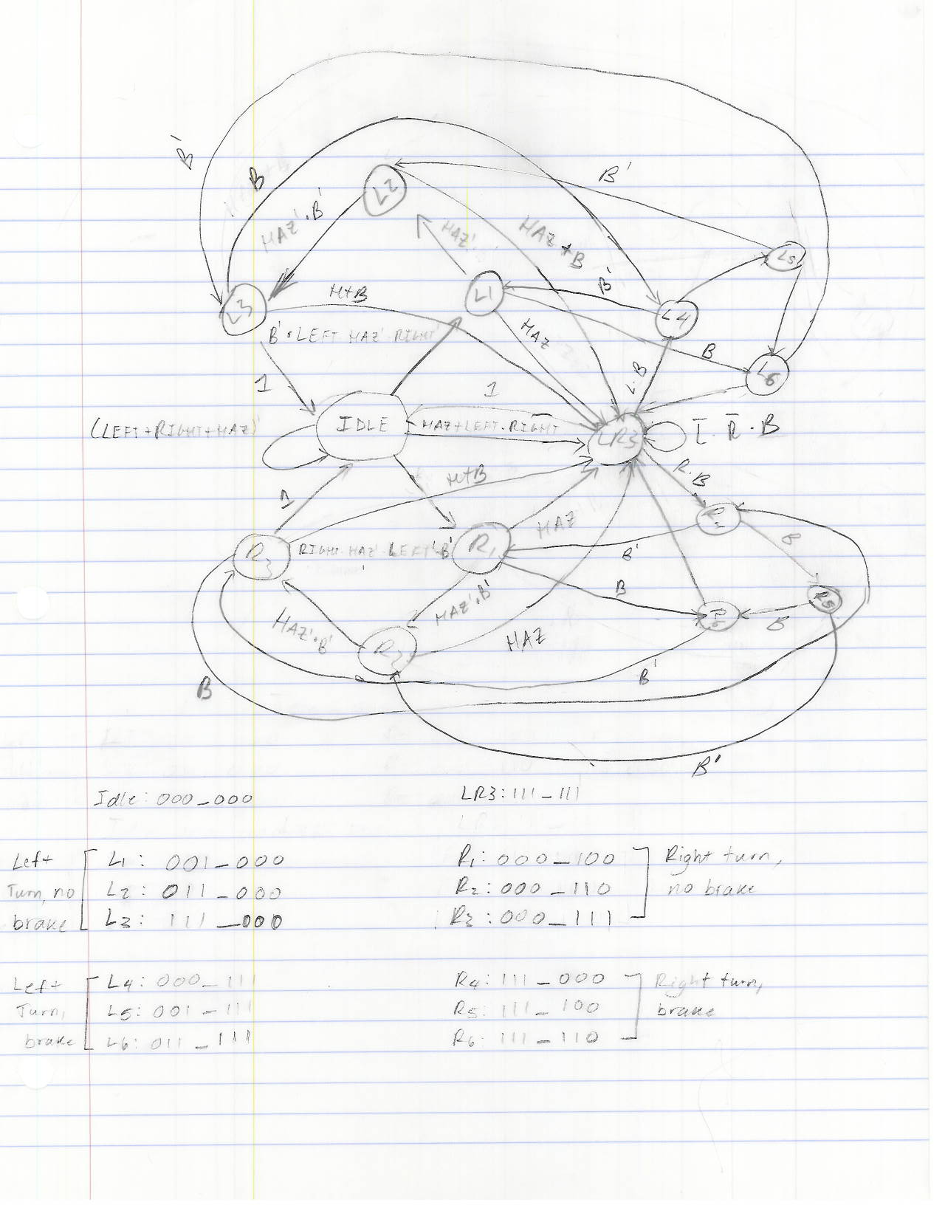

***Figure 1 – Figure 1 contains the State Transition Graph for the T-Bird.***

The T-Bird testbench was also modified to verify that the system transitions to the correct states. First, the system will have the left turn signal activated and then the right signal. Then, the hazards will be activated. From there, the system will turn on the left turn will be activated, and after 20 seconds, the brakes will be activated. Next, the brakes will turn off and after 20 seconds, the left turn also turns on, at which point the right turn signal is activated. After 20 seconds, the brakes turn on and after 60 ns, they will be turn off. After 20 seconds, the right turn signals turns off.

Appendix A

VHDL Code